1. sudo apt-get update

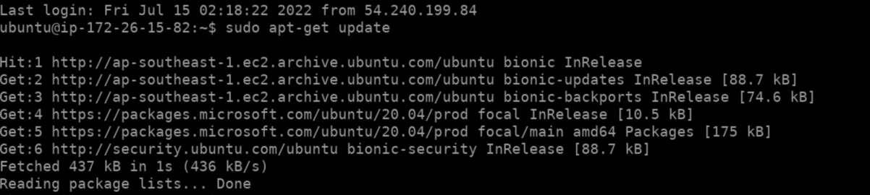

1. sudo apt upgrade

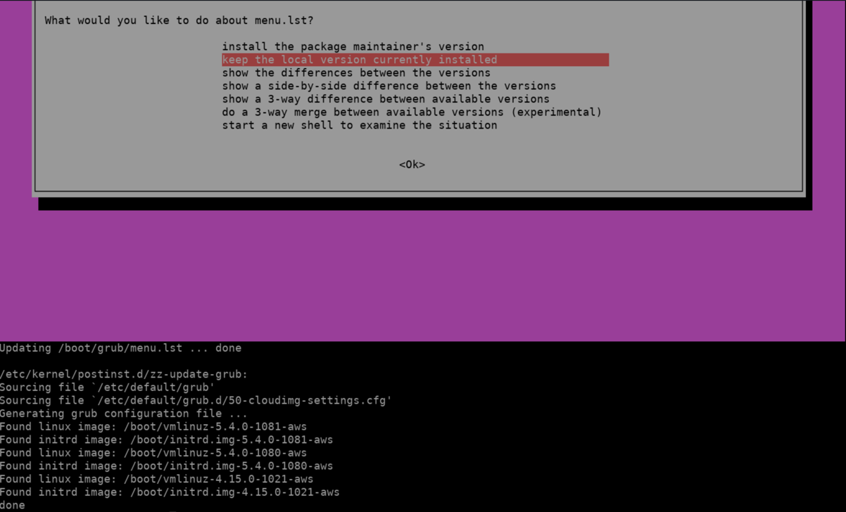

1. sudo apt install zsh

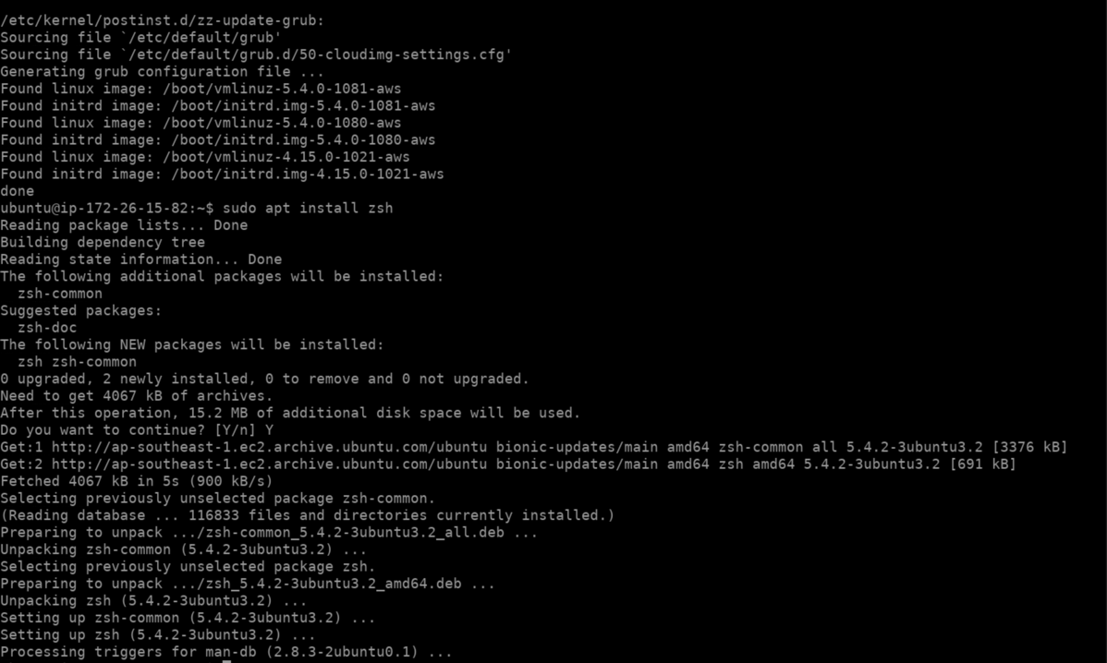

1. sudo apt-get install powerline fonts-powerline

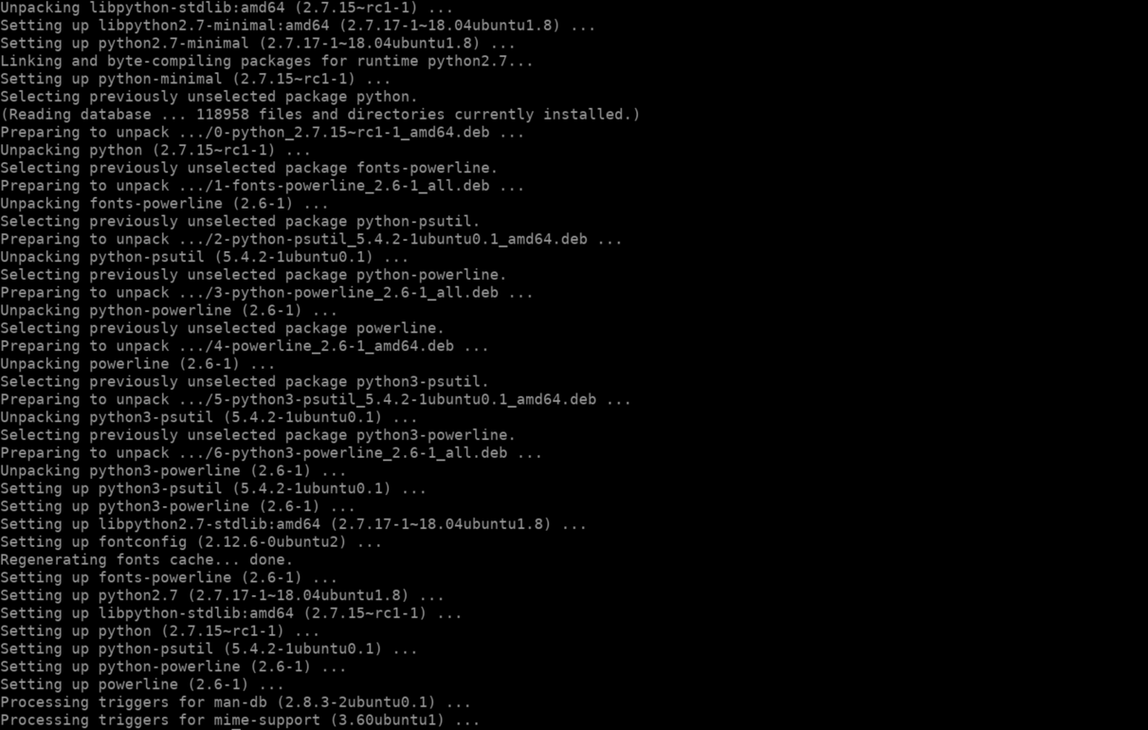

1. git clone https://github.com/robbyrussell/oh-my-zsh.git ~/.oh-my-zsh

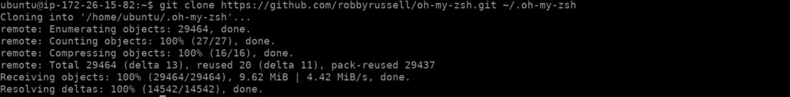

1. Create a New ZSH configuration file and replace ZSH Theme to agnoster

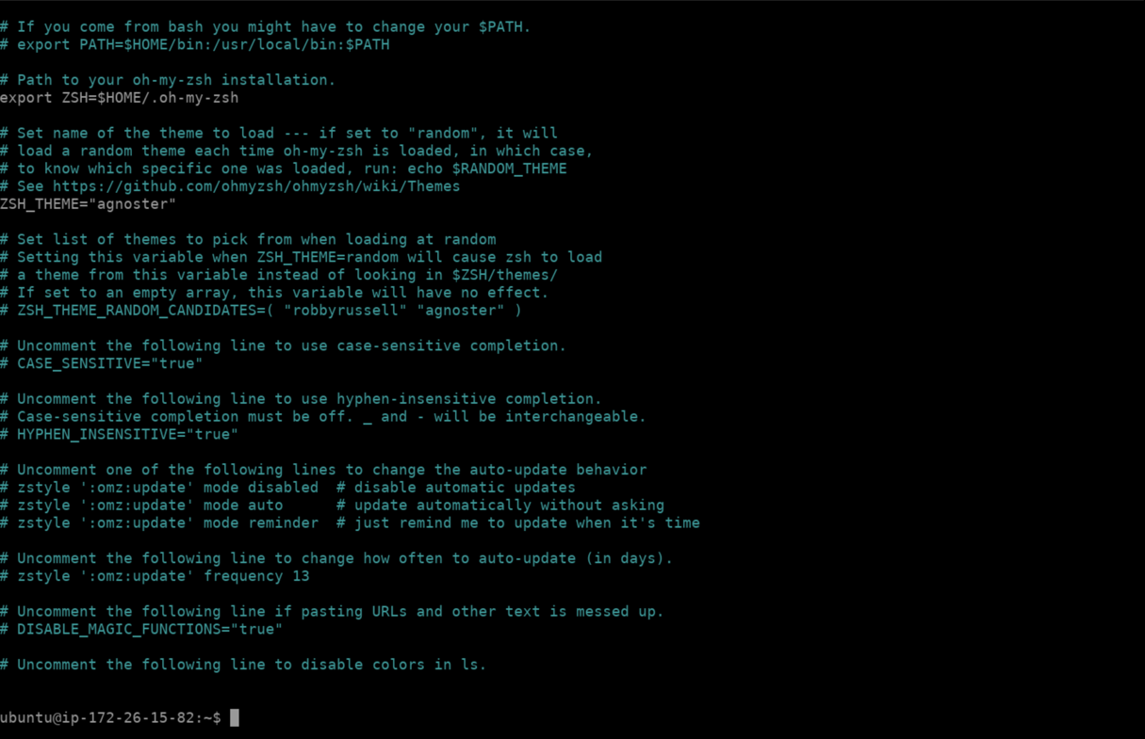

1. git clone https://github.com/zsh-users/zsh-syntax-highlighting.git "$HOME/.zsh-syntax-highlighting" --depth 1

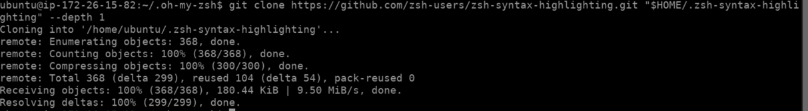

1. Add syntax-highlighting in .zshrc Configuration and Revert Back to Default Shell

